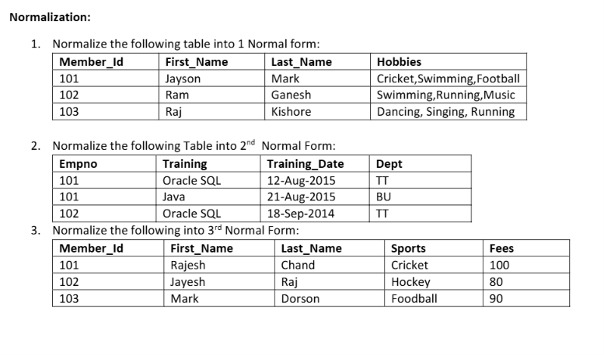
Ans 1. First Normal Form (1NF)
Table: MEMBER_HOBBIES

Member_id |  | First_name |  | Last_name | Hobby
101 |  | Jayson |  | Mark | Cricket
101 |  | Jayson |  | Mark | Swimming
101 |  | Jayson |  | Mark | Football
102 |  | Ram |  | Ganesh | Swimming
102 |  | Ram |  | Ganesh | Running
102 | Ram |  | Ganesh |  |  | Music
103 | Raj |  | Kishore |  |  | Dancing
103 | Raj |  | Kishore |  |  | Singing
103 | Raj |  | kishore |  |  | runningr

Ans2. Second Normal Form (2NF)
Table 1: EMPLOYEE
|Empno |  | dept
101 | TT
102 | TT

Table 2: EMPLOYEE_TRAINING
Empno | Training | Trainig date
101 | Oracle sql | 12 aug 2015
101 | Java | 21 aug 2015
102 | Oracle sql | 18 sep 2014

3. Third Normal Form (3NF)

Table 1: MEMBER
+-----------+------------+-----------+----------+
| Member_Id | First_Name | Last_Name | Sports |
+-----------+------------+-----------+----------+
| 101 | Rajesh | Chand | Cricket |
| 102 | Jayesh | Raj | Hockey |
| 103 | Mark | Dorson | Football |
+-----------+------------+-----------+----------+
Table 2 sports

sports | fees
Cricket |  | 100
Football |  | 90
hockey |  | 80

